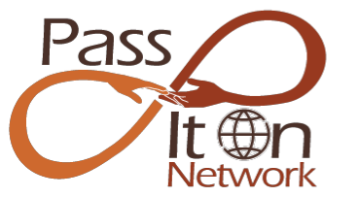
A Global Peer-Learning Network for Positive Ageing Advocates

Bios

Jan Hively (Janet M Hively, PhD)

After a career in city planning and administration, Jan Hively earned her PhD in 2001 at age 69 with a dissertation on “Productive Aging in Rural Communities.” Since then Jan has co-founded several thriving networks that support positive, productive aging, including: the Vital Aging Network, the SHIFT Network, and the global Pass It On Network. A Purpose Prize Fellow, Dr. Hively is a nationally and internationally recognized presenter and consultant for programs that engage older adult leadership and support “meaningful work, paid or unpaid, through the last breath.”

Jan’s academic degrees were earned at Harvard University and the University of Minnesota. Last September, she was profiled in a Forbes article titled, “The Serial Entrepreneur: Is there Life after 50?” The answer is “Yes.”

www.passitonnetwork.org
HIVEL001@umn.edu
508-957-2620

Moira Allan is the co-founder and international coordinator of the Pass It On Network, an Internet platform that connects positive aging advocates from around the world so they can share their strengths to help each other, their communities, and themselves. She serves on the councils of EURAG, Europe’s oldest federation of senior organisations (155 in 32 countries), the International Longevity Center-France and is the international liaison for Old’Up, the cutting edge French association leading the way for the 80+.
She started in journalism and public relations and acquired skills that have served throughout her career as life coach (University Paris 8), trainer, and manager. Moira is from South Africa and has lived in Paris for the last 40 years. She coordinates the Too Young To Retire network in Europe started after the first Positive Aging Conference at Eckerd College, Florida, in 2007 where she met Jan Hively Ph.D. Together they she set out on a collaborative exploration of the longevity revolution. They co-created with World Café Europe, the European Voices for Active Aging (EVAA) project, in 2012 during the European Union’s Year for Active Aging and went on to launch the Pass It On Network in November 2013 in Paris.
moiraallan@yahoo.fr

